DBMS Project

Topic-Car Rental System

Group Involves-RA1911042010102,RA1911042010095,RA1911042010072,RA1911042010065,RA1911042010094

**Queries**

1.Display vehicles which is available.

SELECT Model from car WHERE Status='Available';

2.Display vehicle name having maximum seating capacity.

SELECT Model, MAX(Seating_Capacity) AS max_seating_capacity FROM car GROUP BY Model;

3.Delete all the reservations whose location is in “irving”.

DELETE FROM rental_location WHERE Street_Name LIKE '%Irving%';

4.Find names of Drivers whose last name starts with ‘P’.

SELECT Fname,Lname FROM car_user WHERE LNAME like 'P%';

5.Display the list of additional drivers .

SELECT * from additional_drivers;

6.Show the list of available promo codes.

SELECT Promo_code,Description FROM offer_details WHERE Status='available';

7.Show the driver phone number,licence number whose name is Patrick.

SELECT License_no,Phone FROM `car_user` WHERE Fname='Patrick';

8. Display the type of vehicle having Minimum price.

SELECT Car_Type,MIN(Price_per_day) as min_price FROM car_type;

9.Display the price of car Insurance whose type is 'Comprehesive'.

SELECT Insurance_Price from car_insurance WHERE Insurance_Type='Comprehensive';

10.Write a query to fetch the number of Additional Driver working.

SELECT COUNT(*) FROM additional_driver;

11.Write query to find all the car whose price is between 20 to 100 per day.

SELECT * FROM car_type WHERE Price_Per_Day BETWEEN '20' AND '100';

12. Select all the different values from the Insurance type column in the car insurance table.

SELECT DISTINCT Insurance_type FROM car_insurance;

**ER Diagram-**

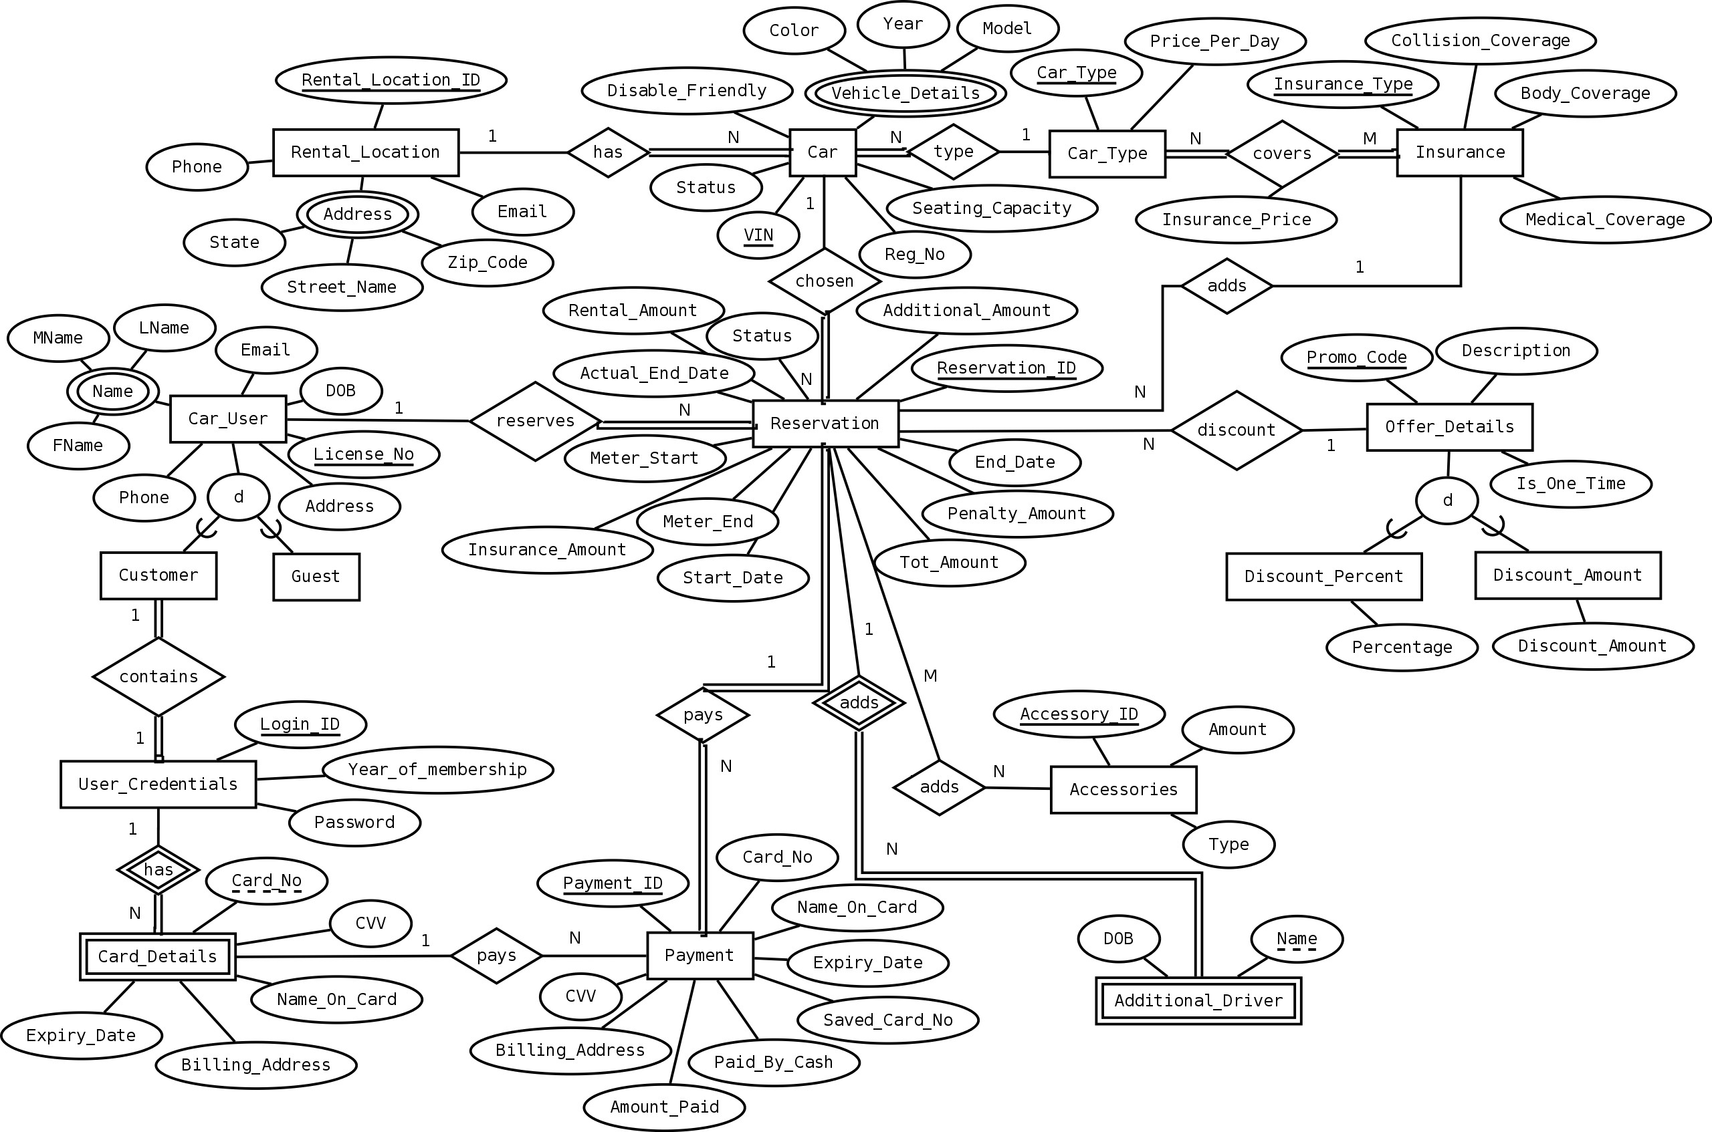

**Schema Diagram:-**

